**Cu dSP**

**(Dilute Sulfuric Peroxide)**

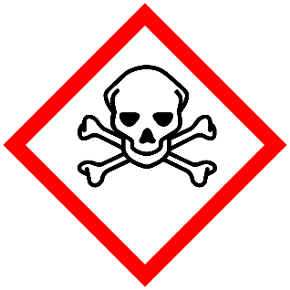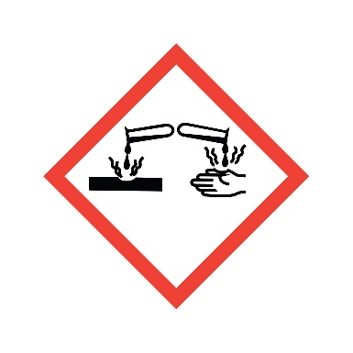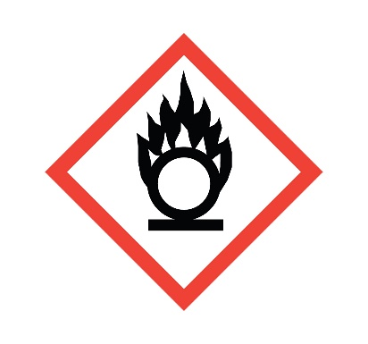

**Danger**

Causes skin irritation and serious eye damage.

**Composition**

**3% H2O2 + 96% H2SO4 + DI Water**